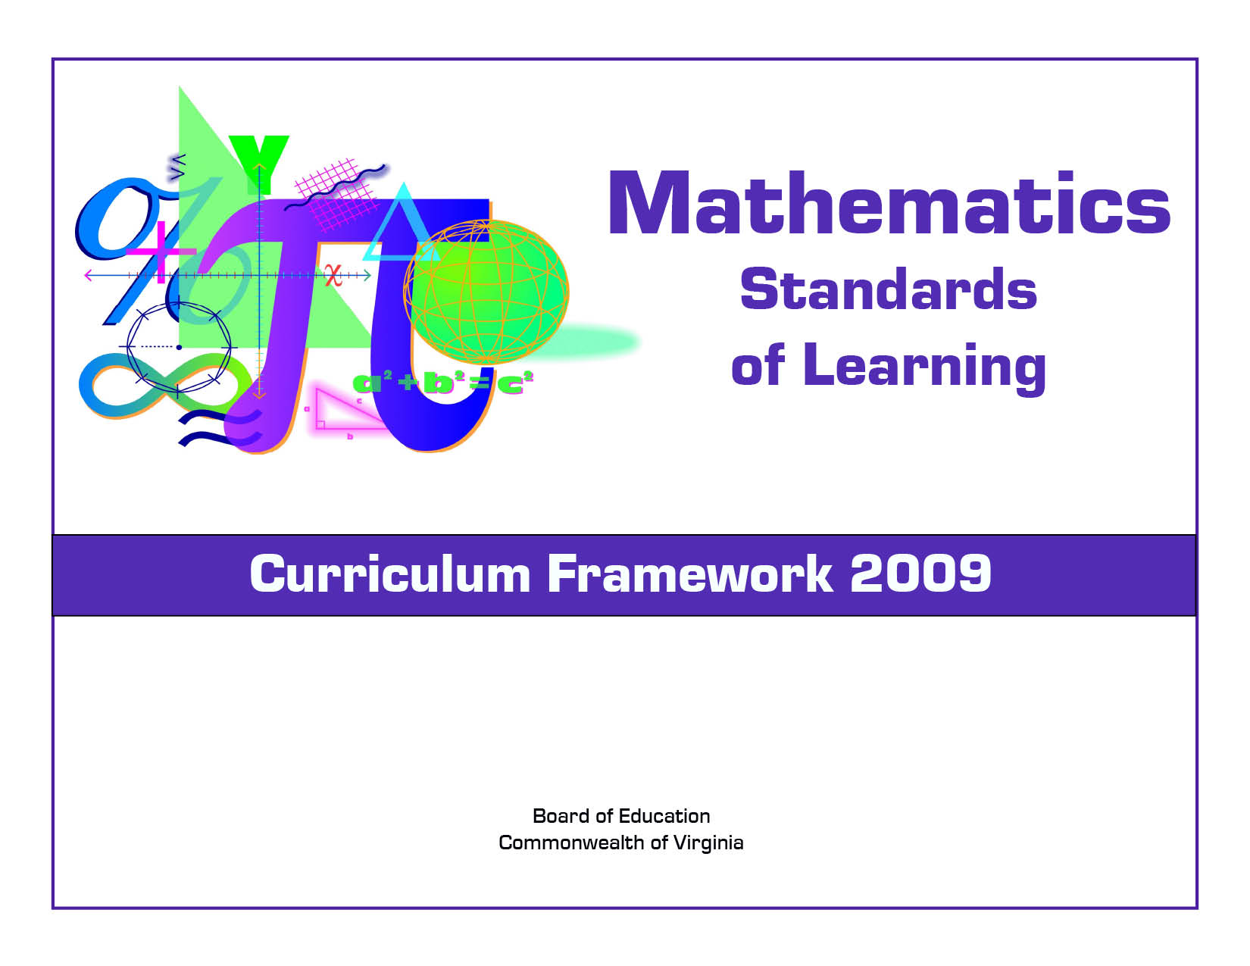
Geometry

Copyright © 2009
by the
Virginia Department of Education
P.O. Box 2120
Richmond, Virginia 23218-2120
http://www.doe.virginia.gov

All rights reserved. Reproduction of these materials for instructional purposes in public school classrooms in Virginia is permitted.

Superintendent of Public Instruction
Patricia I. Wright, Ed.D.

Assistant Superintendent for Instruction
Linda M. Wallinger, Ph.D.

Office of Elementary Instruction
Mark R. Allan, Ph.D., Director
Deborah P. Wickham, Ph.D., Mathematics Specialist

Office of Middle and High School Instruction
Michael F. Bolling, Mathematics Coordinator

Acknowledgements
The Virginia Department of Education wishes to express sincere thanks to Deborah Kiger Bliss, Lois A. Williams, Ed.D., and Felicia Dyke, Ph.D. who assisted in the development of the 2009 Mathematics Standards of Learning Curriculum Framework.

NOTICE
The Virginia Department of Education does not unlawfully discriminate on the basis of race, color, sex, national origin, age, or disability in employment or in its educational programs or services.

The 2009 Mathematics Curriculum Framework can be found in PDF and Microsoft Word file formats on the Virginia Department of Education’s Web site at http://www.doe.virginia.gov.

Virginia Mathematics Standards of Learning Curriculum Framework 2009
Introduction

The 2009 Mathematics Standards of Learning Curriculum Framework is a companion document to the 2009 Mathematics Standards of Learning and amplifies the Mathematics Standards of Learning by defining the content knowledge, skills, and understandings that are measured by the Standards of Learning assessments. The Curriculum Framework provides additional guidance to school divisions and their teachers as they develop an instructional program appropriate for their students. It assists teachers in their lesson planning by identifying essential understandings, defining essential content knowledge, and describing the intellectual skills students need to use. This supplemental framework delineates in greater specificity the content that all teachers should teach and all students should learn.

Each topic in the Mathematics Standards of Learning Curriculum Framework is developed around the Standards of Learning. The format of the Curriculum Framework facilitates teacher planning by identifying the key concepts, knowledge and skills that should be the focus of instruction for each standard. The Curriculum Framework is divided into two columns: Essential Understandings and Essential Knowledge and Skills. The purpose of each column is explained below.

Essential Understandings
This section delineates the key concepts, ideas and mathematical relationships that all students should grasp to demonstrate an understanding of the Standards of Learning.

Essential Knowledge and Skills
Each standard is expanded in the Essential Knowledge and Skills column. What each student should know and be able to do in each standard is outlined. This is not meant to be an exhaustive list nor a list that limits what is taught in the classroom. It is meant to be the key knowledge and skills that define the standard.

The Curriculum Framework serves as a guide for Standards of Learning assessment development. Assessment items may not and should not be a verbatim reflection of the information presented in the Curriculum Framework. Students are expected to continue to apply knowledge and skills from Standards of Learning presented in previous grades as they build mathematical expertise.
TOPIC: reasoning, lines, and transformations
Geometry
Standard G.1
The student will construct and judge the validity of a logical argument consisting of a set of premises and a conclusion. This will include
a) identifying the converse, inverse, and contrapositive of a conditional statement;
b) translating a short verbal argument into symbolic form;
c) using Venn diagrams to represent set relationships; and
d) using deductive reasoning.

Essential Understandings | Essential Knowledge and Skills
- Inductive reasoning, deductive reasoning, and proof are critical in establishing general claims.  - Deductive reasoning is the method that uses logic to draw conclusions based on definitions, postulates, and theorems.  - Inductive reasoning is the method of drawing conclusions from a limited set of observations.  - Proof is a justification that is logically valid and based on initial assumptions, definitions, postulates, and theorems.  - Logical arguments consist of a set of premises or hypotheses and a conclusion.  - Euclidean geometry is an axiomatic system based on undefined terms (point, line and plane), postulates, and theorems.  - When a conditional and its converse are true, the statements can be written as a biconditional, i.e., iff or if and only if.  - Logical arguments that are valid may not be true. Truth and validity are not synonymous. | The student will use problem solving, mathematical communication, mathematical reasoning, connections, and representations to  - Identify the converse, inverse, and contrapositive of a conditional statement.  - Translate verbal arguments into symbolic form, such as (p → q) and (~p → ~q).  - Determine the validity of a logical argument.  - Use valid forms of deductive reasoning, including the law of syllogism, the law of the contrapositive, the law of detachment, and counterexamples.  - Select and use various types of reasoning and methods of proof, as appropriate.  - Use Venn diagrams to represent set relationships, such as intersection and union.  - Interpret Venn diagrams.  - Recognize and use the symbols of formal logic, which include →, ↔, ~, , , and .

TOPIC: reasoning, lines, and transformations
Geometry
Standard G.2
The student will use the relationships between angles formed by two lines cut by a transversal to
a) determine whether two lines are parallel;
b) verify the parallelism, using algebraic and coordinate methods as well as deductive proofs; and
c) solve real-world problems involving angles formed when parallel lines are cut by a transversal.

Essential Understandings | Essential Knowledge and Skills
- Parallel lines intersected by a transversal form angles with specific relationships.  - Some angle relationships may be used when proving two lines intersected by a transversal are parallel.  - The Parallel Postulate differentiates Euclidean from non-Euclidean geometries such as spherical geometry and hyperbolic geometry. | The student will use problem solving, mathematical communication, mathematical reasoning, connections, and representations to  - Use algebraic and coordinate methods as well as deductive proofs to verify whether two lines are parallel.  - Solve problems by using the relationships between pairs of angles formed by the intersection of two parallel lines and a transversal including corresponding angles, alternate interior angles, alternate exterior angles, and same-side (consecutive) interior angles.  - Solve real-world problems involving intersecting and parallel lines in a plane.

TOPIC: reasoning, lines, and transformations
Geometry
Standard G.3
The student will use pictorial representations, including computer software, constructions, and coordinate methods, to solve problems involving symmetry and transformation. This will include
a) investigating and using formulas for finding distance, midpoint, and slope;
b) applying slope to verify and determine whether lines are parallel or perpendicular;
c) investigating symmetry and determining whether a figure is symmetric with respect to a line or a point; and
d) determining whether a figure has been translated, reflected, rotated, or dilated, using coordinate methods.

Essential Understandings | Essential Knowledge and Skills
- Transformations and combinations of transformations can be used to describe movement of objects in a plane.  - The distance formula is an application of the Pythagorean Theorem.  - Geometric figures can be represented in the coordinate plane.  - Techniques for investigating symmetry may include paper folding, coordinate methods, and dynamic geometry software.  - Parallel lines have the same slope.  - The product of the slopes of perpendicular lines is -1.  - The image of an object or function graph after an isomorphic transformation is congruent to the preimage of the object. | The student will use problem solving, mathematical communication, mathematical reasoning, connections, and representations to  - Find the coordinates of the midpoint of a segment, using the midpoint formula.  - Use a formula to find the slope of a line.  - Compare the slopes to determine whether two lines are parallel, perpendicular, or neither.  - Determine whether a figure has point symmetry, line symmetry, both, or neither.  - Given an image and preimage, identify the transformation that has taken place as a reflection, rotation, dilation, or translation.  - Apply the distance formula to find the length of a line segment when given the coordinates of the endpoints.

TOPIC: reasoning, lines, and transformations
Geometry
Standard G.4
The student will construct and justify the constructions of
a) a line segment congruent to a given line segment;
b) the perpendicular bisector of a line segment;
c) a perpendicular to a given line from a point not on the line;
d) a perpendicular to a given line at a given point on the line;
e) the bisector of a given angle;
f) an angle congruent to a given angle; and
g) a line parallel to a given line through a point not on the given line.

Essential Understandings | Essential Knowledge and Skills
- Construction techniques are used to solve real-world problems in engineering, architectural design, and building construction.  - Construction techniques include using a straightedge and compass, paper folding, and dynamic geometry software. | The student will use problem solving, mathematical communication, mathematical reasoning, connections, and representations to  - Construct and justify the constructions of  - a line segment congruent to a given line segment;  - the perpendicular bisector of a line segment;  - a perpendicular to a given line from a point not on the line;  - a perpendicular to a given line at a point on the line;  - the bisector of a given angle;  - an angle congruent to a given angle; and  - a line parallel to a given line through a point not on the given line.  - Construct an equilateral triangle, a square, and a regular hexagon inscribed in a circle.†  - Construct the inscribed and circumscribed circles of a triangle.†  - Construct a tangent line from a point outside a given circle to the circle.†  †Revised March 2011

TOPIC: Triangles
Geometry
Standard G.5
The student, given information concerning the lengths of sides and/or measures of angles in triangles, will
a) order the sides by length, given the angle measures;
b) order the angles by degree measure, given the side lengths;
c) determine whether a triangle exists; and
d) determine the range in which the length of the third side must lie.
These concepts will be considered in the context of real-world situations.

Essential Understandings | Essential Knowledge and Skills
- The longest side of a triangle is opposite the largest angle of the triangle and the shortest side is opposite the smallest angle.  - In a triangle, the length of two sides and the included angle determine the length of the side opposite the angle.  - In order for a triangle to exist, the length of each side must be within a range that is determined by the lengths of the other two sides. | The student will use problem solving, mathematical communication, mathematical reasoning, connections, and representations to  - Order the sides of a triangle by their lengths when given the measures of the angles.  - Order the angles of a triangle by their measures when given the lengths of the sides.  - Given the lengths of three segments, determine whether a triangle could be formed.  - Given the lengths of two sides of a triangle, determine the range in which the length of the third side must lie.  - Solve real-world problems given information about the lengths of sides and/or measures of angles in triangles.

TOPIC: Triangles
Geometry
Standard G.6
The student, given information in the form of a figure or statement, will prove two triangles are congruent, using algebraic and coordinate methods as well as deductive proofs.

Essential Understandings | Essential Knowledge and Skills
- Congruence has real-world applications in a variety of areas, including art, architecture, and the sciences.  - Congruence does not depend on the position of the triangle.  - Concepts of logic can demonstrate congruence or similarity.  - Congruent figures are also similar, but similar figures are not necessarily congruent. | The student will use problem solving, mathematical communication, mathematical reasoning, connections, and representations to  - Use definitions, postulates, and theorems to prove triangles congruent.  - Use coordinate methods, such as the distance formula and the slope formula, to prove two triangles are congruent.  - Use algebraic methods to prove two triangles are congruent.

TOPIC: Triangles
Geometry
Standard G.7
The student, given information in the form of a figure or statement, will prove two triangles are similar, using algebraic and coordinate methods as well as deductive proofs.

Essential Understandings | Essential Knowledge and Skills
- Similarity has real-world applications in a variety of areas, including art, architecture, and the sciences.  - Similarity does not depend on the position of the triangle.  - Congruent figures are also similar, but similar figures are not necessarily congruent. | The student will use problem solving, mathematical communication, mathematical reasoning, connections, and representations to  - Use definitions, postulates, and theorems to prove triangles similar.  - Use algebraic methods to prove that triangles are similar.  - Use coordinate methods, such as the distance formula, to prove two triangles are similar.

TOPIC: Triangles
Geometry
Standard G.8
The student will solve real-world problems involving right triangles by using the Pythagorean Theorem and its converse, properties of special right triangles, and right triangle trigonometry.

Essential Understandings | Essential Knowledge and Skills
- The Pythagorean Theorem is essential for solving problems involving right triangles.  - Many historical and algebraic proofs of the Pythagorean Theorem exist.  - The relationships between the sides and angles of right triangles are useful in many applied fields.  - Some practical problems can be solved by choosing an efficient representation of the problem.  - Another formula for the area of a triangle is.  - The ratios of side lengths in similar right triangles (adjacent/hypotenuse or opposite/hypotenuse) are independent of the scale factor and depend only on the angle the hypotenuse makes with the adjacent side, thus justifying the definition and calculation of trigonometric functions using the ratios of side lengths for similar right triangles. | The student will use problem solving, mathematical communication, mathematical reasoning, connections, and representations to  - Determine whether a triangle formed with three given lengths is a right triangle.  - Solve for missing lengths in geometric figures, using properties of 45°-45°-90° triangles.  - Solve for missing lengths in geometric figures, using properties of 30°-60°-90° triangles.  - Solve problems involving right triangles, using sine, cosine, and tangent ratios.  - Solve real-world problems, using right triangle trigonometry and properties of right triangles.  - Explain and use the relationship between the sine and cosine of complementary angles.†  †Revised March 2011

TOPIC: polygons and circles
Geometry
Standard G.9
The student will verify characteristics of quadrilaterals and use properties of quadrilaterals to solve real-world problems.

Essential Understandings | Essential Knowledge and Skills
- The terms characteristics and properties can be used interchangeably to describe quadrilaterals. The term characteristics is used in elementary and middle school mathematics.  - Quadrilaterals have a hierarchical nature based on the relationships between their sides, angles, and diagonals.  - Characteristics of quadrilaterals can be used to identify the quadrilateral and to find the measures of sides and angles. | The student will use problem solving, mathematical communication, mathematical reasoning, connections, and representations to  - Solve problems, including real-world problems, using the properties specific to parallelograms, rectangles, rhombi, squares, isosceles trapezoids, and trapezoids.  - Prove that quadrilaterals have specific properties, using coordinate and algebraic methods, such as the distance formula, slope, and midpoint formula.  - Prove the characteristics of quadrilaterals, using deductive reasoning, algebraic, and coordinate methods.  - Prove properties of angles for a quadrilateral inscribed in a circle.†  †Revised March 2011

TOPIC: Polygons and Circles
Geometry
Standard G.10
The student will solve real-world problems involving angles of polygons.

Essential Understandings |  | Essential Knowledge and Skills
- A regular polygon will tessellate the plane if the measure of an interior angle is a factor of 360.  - Both regular and nonregular polygons can tessellate the plane.  - Two intersecting lines form angles with specific relationships.  - An exterior angle is formed by extending a side of a polygon.  - The exterior angle and the corresponding interior angle form a linear pair.  - The sum of the measures of the interior angles of a convex polygon may be found by dividing the interior of the polygon into nonoverlapping triangles. | The student will use problem solving, mathematical communication, mathematical reasoning, connections, and representations to  - Solve real-world problems involving the measures of interior and exterior angles of polygons.  - Identify tessellations in art, construction, and nature.  - Find the sum of the measures of the interior and exterior angles of a convex polygon.  - Find the measure of each interior and exterior angle of a regular polygon.  - Find the number of sides of a regular polygon, given the measures of interior or exterior angles of the polygon.

TOPIC: Polygons and Circles
Geometry
Standard G.11
The student will use angles, arcs, chords, tangents, and secants to
a) investigate, verify, and apply properties of circles;
b) solve real-world problems involving properties of circles; and
c) find arc lengths and areas of sectors in circles.

Essential Understandings | Essential Knowledge and Skills
- Many relationships exist between and among angles, arcs, secants, chords, and tangents of a circle.  - All circles are similar.  - A chord is part of a secant.  - Real-world applications may be drawn from architecture, art, and construction. | The student will use problem solving, mathematical communication, mathematical reasoning, connections, and representations to  - Find lengths, angle measures, and arc measures associated with  - two intersecting chords;  - two intersecting secants;  - an intersecting secant and tangent;  - two intersecting tangents; and  - central and inscribed angles.  - Calculate the area of a sector and the length of an arc of a circle, using proportions.  - Solve real-world problems associated with circles, using properties of angles, lines, and arcs.  - Verify properties of circles, using deductive reasoning, algebraic, and coordinate methods.

TOPIC: Polygons and Circles
Geometry
Standard G.12
The student, given the coordinates of the center of a circle and a point on the circle, will write the equation of the circle.

Essential Understandings | Essential Knowledge and Skills
- A circle is a locus of points equidistant from a given point, the center.  - Standard form for the equation of a circle is , where the coordinates of the center of the circle are and is the length of the radius.  - The circle is a conic section. | The student will use problem solving, mathematical communication, mathematical reasoning, connections, and representations to  - Identify the center, radius, and diameter of a circle from a given standard equation.  - Use the distance formula to find the radius of a circle.  - Given the coordinates of the center and radius of the circle, identify a point on the circle.  - Given the equation of a circle in standard form, identify the coordinates of the center and find the radius of the circle.  - Given the coordinates of the endpoints of a diameter, find the equation of the circle.  - Given the coordinates of the center and a point on the circle, find the equation of the circle.  - Recognize that the equation of a circle of given center and radius is derived using the Pythagorean Theorem.†  †Revised March 2011

TOPIC: Three-Dimensional Figures
Geometry
Standard G.13
The student will use formulas for surface area and volume of three-dimensional objects to solve real-world problems.

Essential Understandings | Essential Knowledge and Skills
- The surface area of a three-dimensional object is the sum of the areas of all its faces.  - The volume of a three-dimensional object is the number of unit cubes that would fill the object. | The student will use problem solving, mathematical communication, mathematical reasoning, connections, and representations to  - Find the total surface area of cylinders, prisms, pyramids, cones, and spheres, using the appropriate formulas.  - Calculate the volume of cylinders, prisms, pyramids, cones, and spheres, using the appropriate formulas.  - Solve problems, including real-world problems, involving total surface area and volume of cylinders, prisms, pyramids, cones, and spheres as well as combinations of three-dimensional figures.  - Calculators may be used to find decimal approximations for results.

TOPIC: Three-Dimensional Figures
Geometry
Standard G.14
The student will use similar geometric objects in two- or three-dimensions to
a) compare ratios between side lengths, perimeters, areas, and volumes;
b) determine how changes in one or more dimensions of an object affect area and/or volume of the object;
c) determine how changes in area and/or volume of an object affect one or more dimensions of the object; and
d) solve real-world problems about similar geometric objects.

Essential Understandings | Essential Knowledge and Skills
- A change in one dimension of an object results in predictable changes in area and/or volume.  - A constant ratio exists between corresponding lengths of sides of similar figures.  - Proportional reasoning is integral to comparing attribute measures in similar objects. | The student will use problem solving, mathematical communication, mathematical reasoning, connections, and representations to  - Compare ratios between side lengths, perimeters, areas, and volumes, given two similar figures.  - Describe how changes in one or more dimensions affect other derived measures (perimeter, area, total surface area, and volume) of an object.  - Describe how changes in one or more measures (perimeter, area, total surface area, and volume) affect other measures of an object.  - Solve real-world problems involving measured attributes of similar objects.

