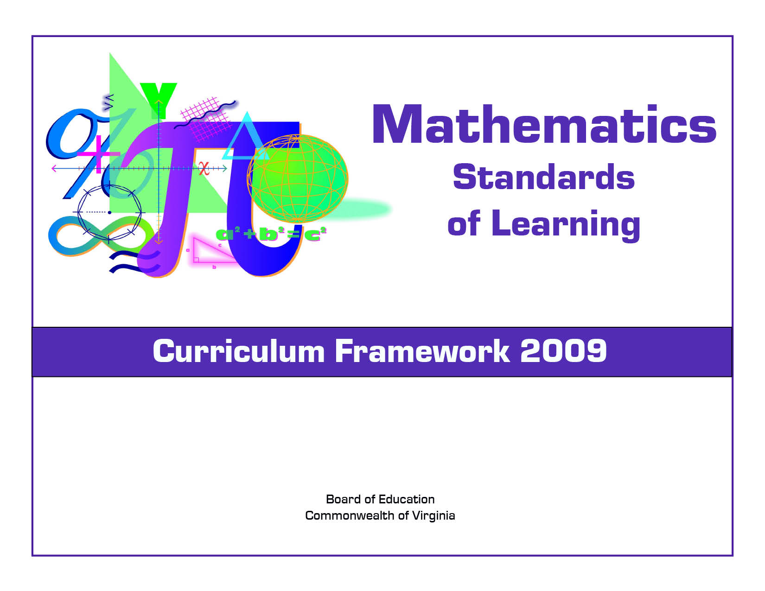
Algebra II

Copyright © 2009
by the
Virginia Department of Education
P.O. Box 2120
Richmond, Virginia 23218-2120
http://www.doe.virginia.gov

All rights reserved. Reproduction of these materials for instructional purposes in public school classrooms in Virginia is permitted.

Superintendent of Public Instruction
Patricia I. Wright, Ed.D.

Assistant Superintendent for Instruction
Linda M. Wallinger, Ph.D.

Office of Elementary Instruction
Mark R. Allan, Ph.D., Director
Deborah P. Wickham, Ph.D., Mathematics Specialist

Office of Middle and High School Instruction
Michael F. Bolling, Mathematics Coordinator

Acknowledgements
The Virginia Department of Education wishes to express sincere thanks to Deborah Kiger Bliss, Lois A. Williams, Ed.D., and Felicia Dyke, Ph.D. who assisted in the development of the 2009 Mathematics Standards of Learning Curriculum Framework.

NOTICE
The Virginia Department of Education does not unlawfully discriminate on the basis of race, color, sex, national origin, age, or disability in employment or in its educational programs or services.

The 2009 Mathematics Curriculum Framework can be found in PDF and Microsoft Word file formats on the Virginia Department of Education’s Web site at http://www.doe.virginia.gov.
Virginia Mathematics Standards of Learning Curriculum Framework 2009
Introduction

The 2009 Mathematics Standards of Learning Curriculum Framework is a companion document to the 2009 Mathematics Standards of Learning and amplifies the Mathematics Standards of Learning by defining the content knowledge, skills, and understandings that are measured by the Standards of Learning assessments. The Curriculum Framework provides additional guidance to school divisions and their teachers as they develop an instructional program appropriate for their students. It assists teachers in their lesson planning by identifying essential understandings, defining essential content knowledge, and describing the intellectual skills students need to use. This supplemental framework delineates in greater specificity the content that all teachers should teach and all students should learn.

Each topic in the Mathematics Standards of Learning Curriculum Framework is developed around the Standards of Learning. The format of the Curriculum Framework facilitates teacher planning by identifying the key concepts, knowledge and skills that should be the focus of instruction for each standard. The Curriculum Framework is divided into two columns: Essential Understandings and Essential Knowledge and Skills. The purpose of each column is explained below.

Essential Understandings
This section delineates the key concepts, ideas and mathematical relationships that all students should grasp to demonstrate an understanding of the Standards of Learning.

Essential Knowledge and Skills
Each standard is expanded in the Essential Knowledge and Skills column. What each student should know and be able to do in each standard is outlined. This is not meant to be an exhaustive list nor a list that limits what is taught in the classroom. It is meant to be the key knowledge and skills that define the standard.

The Curriculum Framework serves as a guide for Standards of Learning assessment development. Assessment items may not and should not be a verbatim reflection of the information presented in the Curriculum Framework. Students are expected to continue to apply knowledge and skills from Standards of Learning presented in previous grades as they build mathematical expertise.
TOPic: Expressions and Operations
Algebra II
Standard AII.1
The student, given rational, radical, or polynomial expressions, will
a) add, subtract, multiply, divide, and simplify rational algebraic expressions;
b) add, subtract, multiply, divide, and simplify radical expressions containing rational numbers and variables, and expressions containing rational exponents;
c) write radical expressions as expressions containing rational exponents and vice versa; and
d) factor polynomials completely.

Essential Understandings | Essential Knowledge and Skills
- Computational skills applicable to numerical fractions also apply to rational expressions involving variables.  - Radical expressions can be written and simplified using rational exponents.  - Only radicals with a common radicand and index can be added or subtracted.  - A relationship exists among arithmetic complex fractions, algebraic complex fractions, and rational numbers.  - The complete factorization of polynomials has occurred when each factor is a prime polynomial.  - Pattern recognition can be used to determine complete factorization of a polynomial. | The student will use problem solving, mathematical communication, mathematical reasoning, connections, and representations to  - Add, subtract, multiply, and divide rational algebraic expressions.  - Simplify a rational algebraic expression with common monomial or binomial factors.  - Recognize a complex algebraic fraction, and simplify it as a quotient or product of simple algebraic fractions.  - Simplify radical expressions containing positive rational numbers and variables.  - Convert from radical notation to exponential notation, and vice versa.  - Add and subtract radical expressions.  - Multiply and divide radical expressions not requiring rationalizing the denominators.  - Factor polynomials by applying general patterns including difference of squares, sum and difference of cubes, and perfect square trinomials.  - Factor polynomials completely over the integers.  - Verify polynomial identities including the difference of squares, sum and difference of cubes, and perfect square trinomials.†  †Revised March 2011

Topic: Functions
Algebra II
Standard AII.2
The student will investigate and apply the properties of arithmetic and geometric sequences and series to solve real-world problems, including writing the first n terms, finding the n^{th} term, and evaluating summation formulas. Notation will include ∑ and a_{n}.

Essential Understandings | Essential Knowledge and Skills
- Sequences and series arise from real-world situations.  - The study of sequences and series is an application of the investigation of patterns.  - A sequence is a function whose domain is the set of natural numbers.  - Sequences can be defined explicitly and recursively. | The student will use problem solving, mathematical communication, mathematical reasoning, connections, and representations to  - Distinguish between a sequence and a series.  - Generalize patterns in a sequence using explicit and recursive formulas.  - Use and interpret the notations ∑, n, n^{th} term, and a_{n}.  - Given the formula, find a_{n} (the n^{th} term) for an arithmetic or a geometric sequence.  - Given formulas, write the first n terms and find the sum, S_{n,} of the first n terms of an arithmetic or geometric series.  - Given the formula, find the sum of a convergent infinite series.  - Model real-world situations using sequences and series.

Topic: Expressions and Operations
Algebra II
Standard AII.3
The student will perform operations on complex numbers, express the results in simplest form using patterns of the powers of i, and identify field properties that are valid for the complex numbers.

Essential Understandings | Essential Knowledge and Skills
- Complex numbers are organized into a hierarchy of subsets.  - A complex number multiplied by its conjugate is a real number.  - Equations having no real number solutions may have solutions in the set of complex numbers.  - Field properties apply to complex numbers as well as real numbers.  - All complex numbers can be written in the form a+bi where a and b are real numbers and i is. | The student will use problem solving, mathematical communication, mathematical reasoning, connections, and representations to  - Recognize that the square root of –1 is represented as i.  - Determine which field properties apply to the complex number system.  - Simplify radical expressions containing negative rational numbers and express in a+bi form.  - Simplify powers of i.  - Add, subtract, and multiply complex numbers.  - Place the following sets of numbers in a hierarchy of subsets: complex, pure imaginary, real, rational, irrational, integers, whole, and natural.  - Write a real number in a+bi form.  - Write a pure imaginary number in a+bi form.

Topic: Equations and Inequalities
Algebra II
Standard AII.4
The student will solve, algebraically and graphically,
a) absolute value equations and inequalities;
b) quadratic equations over the set of complex numbers;
c) equations containing rational algebraic expressions; and
d) equations containing radical expressions.
Graphing calculators will be used for solving and for confirming the algebraic solutions.

Essential Understandings | Essential Knowledge and Skills
- A quadratic function whose graph does not intersect the x-axis has roots with imaginary components.  - The quadratic formula can be used to solve any quadratic equation.  - The value of the discriminant of a quadratic equation can be used to describe the number of real and complex solutions.  - The definition of absolute value (for any real numbers a and b, where b 0, if , then a = b or a = - b) is used in solving absolute value equations and inequalities.  - Absolute value inequalities can be solved graphically or by using a compound statement.  - Real-world problems can be interpreted, represented, and solved using equations and inequalities.  - The process of solving radical or rational equations can lead to extraneous solutions.  - Equations can be solved in a variety of ways.  - Set builder notation may be used to represent solution sets of equations and inequalities. | The student will use problem solving, mathematical communication, mathematical reasoning, connections, and representations to  - Solve absolute value equations and inequalities algebraically and graphically.  - Solve a quadratic equation over the set of complex numbers using an appropriate strategy.  - Calculate the discriminant of a quadratic equation to determine the number of real and complex solutions.  - Solve equations containing rational algebraic expressions with monomial or binomial denominators algebraically and graphically.  - Solve an equation containing a radical expression algebraically and graphically.  - Verify possible solutions to an equation containing rational or radical expressions.  - Apply an appropriate equation to solve a real-world problem.  - Recognize that the quadratic formula can be derived by applying the completion of squares to any quadratic equation in standard form.†  †Revised March 2011

Topic: Equations and Inequalities
Algebra II
Standard AII.5
The student will solve nonlinear systems of equations, including linear-quadratic and quadratic-quadratic, algebraically and graphically. Graphing calculators will be used as a tool to visualize graphs and predict the number of solutions.

Essential Understandings | Essential Knowledge and Skills
- Solutions of a nonlinear system of equations are numerical values that satisfy every equation in the system.  - The coordinates of points of intersection in any system of equations are solutions to the system.  - Real-world problems can be interpreted, represented, and solved using systems of equations. | The student will use problem solving, mathematical communication, mathematical reasoning, connections, and representations to  - Predict the number of solutions to a nonlinear system of two equations.  - Solve a linear-quadratic system of two equations algebraically and graphically.  - Solve a quadratic-quadratic system of two equations algebraically and graphically.

Topic: Functions
Algebra II
Standard AII.6
The student will recognize the general shape of function (absolute value, square root, cube root, rational, polynomial, exponential, and logarithmic) families and will convert between graphic and symbolic forms of functions. A transformational approach to graphing will be employed. Graphing calculators will be used as a tool to investigate the shapes and behaviors of these functions.

Essential Understandings | Essential Knowledge and Skills
- The graphs/equations for a family of functions can be determined using a transformational approach.  - Transformations of graphs include translations, reflections, and dilations.  - A parent graph is an anchor graph from which other graphs are derived with transformations. | The student will use problem solving, mathematical communication, mathematical reasoning, connections, and representations to  - Recognize graphs of parent functions.  - Given a transformation of a parent function, identify the graph of the transformed function.  - Given the equation and using a transformational approach, graph a function.  - Given the graph of a function, identify the parent function.  - Given the graph of a function, identify the transformations that map the preimage to the image in order to determine the equation of the image.  - Using a transformational approach, write the equation of a function given its graph.

Topic: Functions
Algebra II
Standard AII.7
The student will investigate and analyze functions algebraically and graphically. Key concepts include
a) domain and range, including limited and discontinuous domains and ranges;
b) zeros;
c) x- and y-intercepts;
d) intervals in which a function is increasing or decreasing;
e) asymptotes;
f) end behavior;
g) inverse of a function; and
h) composition of multiple functions.
Graphing calculators will be used as a tool to assist in investigation of functions.

Essential Understandings | Essential Knowledge and Skills
- Functions may be used to model real-world situations.  - The domain and range of a function may be restricted algebraically or by the real-world situation modeled by the function.  - A function can be described on an interval as increasing, decreasing, or constant.  - Asymptotes may describe both local and global behavior of functions.  - End behavior describes a function as x approaches positive and negative infinity.  - A zero of a function is a value of x that makesequal zero.  - If (a, b) is an element of a function, then (b, a) is an element of the inverse of the function.  - Exponential () and logarithmic () functions are inverses of each other.  - Functions can be combined using composition of functions. | The student will use problem solving, mathematical communication, mathematical reasoning, connections, and representations to  - Identify the domain, range, zeros, and intercepts of a function presented algebraically or graphically.  - Describe restricted/discontinuous domains and ranges.  - Given the graph of a function, identify intervals on which the function is increasing and decreasing.  - Find the equations of vertical and horizontal asymptotes of functions.  - Describe the end behavior of a function.  - Find the inverse of a function.  - Graph the inverse of a function as a reflection across the line y = x.  - Investigate exponential and logarithmic functions, using the graphing calculator.  - Convert between logarithmic and exponential forms of an equation with bases consisting of natural numbers.  - Find the composition of two functions.  - Use composition of functions to verify two functions are inverses.

Topic: Functions
Algebra II
Standard AII.8
The student will investigate and describe the relationships among solutions of an equation, zeros of a function, x-intercepts of a graph, and factors of a polynomial expression.

Essential Understandings | Essential Knowledge and Skills
- The Fundamental Theorem of Algebra states that, including complex and repeated solutions, an n^{th} degree polynomial equation has exactly n roots (solutions).  - The following statements are equivalent:  - k is a zero of the polynomial function f;  - (x – k) is a factor of f(x);  - k is a solution of the polynomial equation f(x) = 0; and  - k is an x-intercept for the graph of y = f(x). | The student will use problem solving, mathematical communication, mathematical reasoning, connections, and representations to  - Describe the relationships among solutions of an equation, zeros of a function, x-intercepts of a graph, and factors of a polynomial expression.  - Define a polynomial function, given its zeros.  - Determine a factored form of a polynomial expression from the x-intercepts of the graph of its corresponding function.  - For a function, identify zeros of multiplicity greater than 1 and describe the effect of those zeros on the graph of the function.  - Given a polynomial equation, determine the number of real solutions and nonreal solutions.

Topic: STATISTICS
Algebra II
Standard AII.9
The student will collect and analyze data, determine the equation of the curve of best fit, make predictions, and solve real-world problems, using mathematical models. Mathematical models will include polynomial, exponential, and logarithmic functions.

Essential Understandings | Essential Knowledge and Skills
- Data and scatterplots may indicate patterns that can be modeled with an algebraic equation.  - Graphing calculators can be used to collect, organize, picture, and create an algebraic model of the data.  - Data that fit polynomial (, where n is a nonnegative integer, and the coefficients are real numbers), exponential (), and logarithmic () models arise from real-world situations. | The student will use problem solving, mathematical communication, mathematical reasoning, connections, and representations to  - Collect and analyze data.  - Investigate scatterplots to determine if patterns exist and then identify the patterns.  - Find an equation for the curve of best fit for data, using a graphing calculator. Models will include polynomial, exponential, and logarithmic functions.  - Make predictions, using data, scatterplots, or the equation of the curve of best fit.  - Given a set of data, determine the model that would best describe the data.

Topic: statistics
Algebra II
Standard AII.10
The student will identify, create, and solve real-world problems involving inverse variation, joint variation, and a combination of direct and inverse variations.

Essential Understandings | Essential Knowledge and Skills
- Real-world problems can be modeled and solved by using inverse variation, joint variation, and a combination of direct and inverse variations.  - Joint variation is a combination of direct variations. | The student will use problem solving, mathematical communication, mathematical reasoning, connections, and representations to  - Translate “y varies jointly as x and z” as y = kxz.  - Translate “y is directly proportional to x” as y = kx.  - Translate “y is inversely proportional to x” as y = .  - Given a situation, determine the value of the constant of proportionality.  - Set up and solve problems, including real-world problems, involving inverse variation, joint variation, and a combination of direct and inverse variations.

Topic: statistics
Algebra II
Standard AII.11
The student will identify properties of a normal distribution and apply those properties to determine probabilities associated with areas under the standard normal curve.

Essential Understandings | Essential Knowledge and Skills
- A normal distribution curve is a symmetrical, bell-shaped curve defined by the mean and the standard deviation of a data set. The mean is located on the line of symmetry of the curve.  - Areas under the curve represent probabilities associated with continuous distributions.  - The normal curve is a probability distribution and the total area under the curve is 1.  - For a normal distribution, approximately 68 percent of the data fall within one standard deviation of the mean, approximately 95 percent of the data fall within two standard deviations of the mean, and approximately 99.7 percent of the data fall within three standard deviations of the mean.  - The mean of the data in a standard normal distribution is 0 and the standard deviation is 1.  - The standard normal curve allows for the comparison of data from different normal distributions.  - A z-score is a measure of position derived from the mean and standard deviation of data.  - A z-score expresses, in standard deviation units, how far an element falls from the mean of the data set.  - A z-score is a derived score from a given normal distribution.  - A standard normal distribution is the set of all z-scores. | The student will use problem solving, mathematical communication, mathematical reasoning, connections, and representations to  - Identify the properties of a normal probability distribution.  - Describe how the standard deviation and the mean affect the graph of the normal distribution.  - Compare two sets of normally distributed data using a standard normal distribution and z-scores.  - Represent probability as area under the curve of a standard normal probability distribution.  - Use the graphing calculator or a standard normal probability table to determine probabilities or percentiles based on z-scores.

Topic: statistics
Algebra II
Standard AII.12
The student will compute and distinguish between permutations and combinations and use technology for applications.

Essential Understandings | Essential Knowledge and Skills
- The Fundamental Counting Principle states that if one decision can be made n ways and another can be made m ways, then the two decisions can be made nm ways.  - Permutations are used to calculate the number of possible arrangements of objects.  - Combinations are used to calculate the number of possible selections of objects without regard to the order selected. | The student will use problem solving, mathematical communication, mathematical reasoning, connections, and representations to  - Compare and contrast permutations and combinations.  - Calculate the number of permutations of n objects taken r at a time.  - Calculate the number of combinations of n objects taken r at a time.  - Use permutations and combinations as counting techniques to solve real-world problems.

