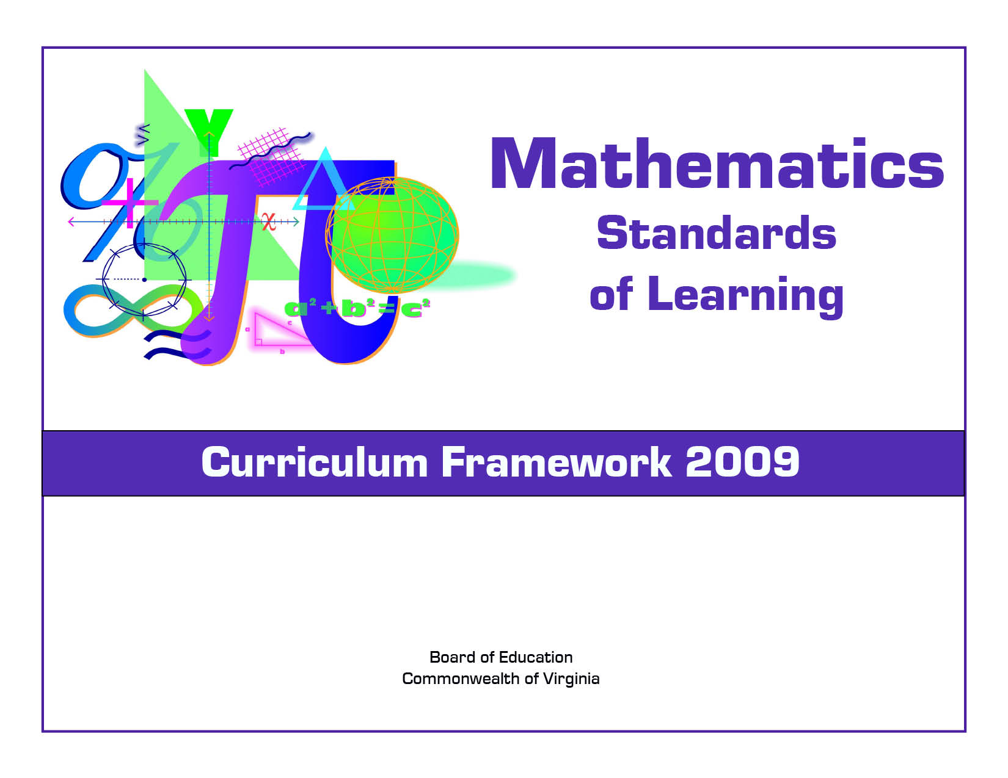
Algebra I

Copyright © 2009
by the
Virginia Department of Education
P.O. Box 2120
Richmond, Virginia 23218-2120
http://www.doe.virginia.gov

All rights reserved. Reproduction of these materials for instructional purposes in public school classrooms in Virginia is permitted.

Superintendent of Public Instruction
Patricia I. Wright, Ed.D.

Assistant Superintendent for Instruction
Linda M. Wallinger, Ph.D.

Office of Elementary Instruction
Mark R. Allan, Ph.D., Director
Deborah P. Wickham, Ph.D., Mathematics Specialist

Office of Middle and High School Instruction
Michael F. Bolling, Mathematics Coordinator

Acknowledgements
The Virginia Department of Education wishes to express sincere thanks to Deborah Kiger Bliss, Lois A. Williams, Ed.D., and Felicia Dyke, Ph.D. who assisted in the development of the 2009 Mathematics Standards of Learning Curriculum Framework.

NOTICE
The Virginia Department of Education does not unlawfully discriminate on the basis of race, color, sex, national origin, age, or disability in employment or in its educational programs or services.

The 2009 Mathematics Curriculum Framework can be found in PDF and Microsoft Word file formats on the Virginia Department of Education’s Web site at http://www.doe.virginia.gov.

Virginia Mathematics Standards of Learning Curriculum Framework 2009
Introduction

The 2009 Mathematics Standards of Learning Curriculum Framework is a companion document to the 2009 Mathematics Standards of Learning and amplifies the Mathematics Standards of Learning by defining the content knowledge, skills, and understandings that are measured by the Standards of Learning assessments. The Curriculum Framework provides additional guidance to school divisions and their teachers as they develop an instructional program appropriate for their students. It assists teachers in their lesson planning by identifying essential understandings, defining essential content knowledge, and describing the intellectual skills students need to use. This supplemental framework delineates in greater specificity the content that all teachers should teach and all students should learn.

Each topic in the Mathematics Standards of Learning Curriculum Framework is developed around the Standards of Learning. The format of the Curriculum Framework facilitates teacher planning by identifying the key concepts, knowledge and skills that should be the focus of instruction for each standard. The Curriculum Framework is divided into two columns: Essential Understandings and Essential Knowledge and Skills. The purpose of each column is explained below.

Essential Understandings
This section delineates the key concepts, ideas and mathematical relationships that all students should grasp to demonstrate an understanding of the Standards of Learning.

Essential Knowledge and Skills
Each standard is expanded in the Essential Knowledge and Skills column. What each student should know and be able to do in each standard is outlined. This is not meant to be an exhaustive list nor a list that limits what is taught in the classroom. It is meant to be the key knowledge and skills that define the standard.

The Curriculum Framework serves as a guide for Standards of Learning assessment development. Assessment items may not and should not be a verbatim reflection of the information presented in the Curriculum Framework. Students are expected to continue to apply knowledge and skills from Standards of Learning presented in previous grades as they build mathematical expertise.
Topic: Expressions and Operations
Algebra I
Standard A.1
The student will represent verbal quantitative situations algebraically and evaluate these expressions for given replacement values of the variables.

Essential Understandings | Essential Knowledge and Skills
- Algebra is a tool for reasoning about quantitative situations so that relationships become apparent.  - Algebra is a tool for describing and representing patterns and relationships.  - Mathematical modeling involves creating algebraic representations of quantitative real-world situations.  - The numerical value of an expression is dependent upon the values of the replacement set for the variables.  - There are a variety of ways to compute the value of a numerical expression and evaluate an algebraic expression.  - The operations and the magnitude of the numbers in an expression impact the choice of an appropriate computational technique.  - An appropriate computational technique could be mental mathematics, calculator, or paper and pencil. | The student will use problem solving, mathematical communication, mathematical reasoning, connections, and representations to  - Translate verbal quantitative situations into algebraic expressions and vice versa.  - Model real-world situations with algebraic expressions in a variety of representations (concrete, pictorial, symbolic, verbal).  - Evaluate algebraic expressions for a given replacement set to include rational numbers.  - Evaluate expressions that contain absolute value, square roots, and cube roots.

Topic: Expressions and Operations
Algebra I
Standard A.2
The student will perform operations on polynomials, including
a) applying the laws of exponents to perform operations on expressions;
b) adding, subtracting, multiplying, and dividing polynomials; and
c) factoring completely first- and second-degree binomials and trinomials in one or two variables. Graphing calculators will be used as a tool for factoring and for confirming algebraic factorizations.

Essential Understandings | Essential Knowledge and Skills
- The laws of exponents can be investigated using inductive reasoning.  - A relationship exists between the laws of exponents and scientific notation.  - Operations with polynomials can be represented concretely, pictorially, and symbolically.  - Polynomial expressions can be used to model real-world situations.  - The distributive property is the unifying concept for polynomial operations.  - Factoring reverses polynomial multiplication.  - Some polynomials are prime polynomials and cannot be factored over the set of real numbers.  - Polynomial expressions can be used to define functions and these functions can be represented graphically.  - There is a relationship between the factors of any polynomial and the x-intercepts of the graph of its related function. | The student will use problem solving, mathematical communication, mathematical reasoning, connections, and representations to  - Simplify monomial expressions and ratios of monomial expressions in which the exponents are integers, using the laws of exponents.  - Model sums, differences, products, and quotients of polynomials with concrete objects and their related pictorial representations.  - Relate concrete and pictorial manipulations that model polynomial operations to their corresponding symbolic representations.  - Find sums and differences of polynomials.  - Find products of polynomials. The factors will have no more than five total terms (i.e. (4x+2)(3x+5) represents four terms and (x+1)(2x² +x+3) represents five terms).  - Find the quotient of polynomials, using a monomial or binomial divisor, or a completely factored divisor.  - Factor completely first- and second-degree polynomials with integral coefficients.  - Identify prime polynomials.  - Use the x-intercepts from the graphical representation of the polynomial to determine and confirm its factors.

Topic: Expressions and Operations
Algebra I
Standard A.3
The student will express the square roots and cube roots of whole numbers and the square root of a monomial algebraic expression in simplest radical form.

Essential Understandings | Essential Knowledge and Skills
- A square root in simplest form is one in which the radicand (argument) has no perfect square factors other than one.  - A cube root in simplest form is one in which the argument has no perfect cube factors other than one.  - The cube root of a perfect cube is an integer.  - The cube root of a nonperfect cube lies between two consecutive integers.  - The inverse of cubing a number is determining the cube root.  - In the real number system, the argument of a square root must be nonnegative while the argument of a cube root may be any real number. | The student will use problem solving, mathematical communication, mathematical reasoning, connections, and representations to  - Express square roots of a whole number in simplest form.  - Express the cube root of a whole number in simplest form.  - Express the principal square root of a monomial algebraic expression in simplest form where variables are assumed to have positive values.

Topic: Equations and inequalities
Algebra I
Standard A.4
The student will solve multistep linear and quadratic equations in two variables, including
a) solving literal equations (formulas) for a given variable;
b) justifying steps used in simplifying expressions and solving equations, using field properties and axioms of equality that are valid for the set of real numbers and its subsets;
c) solving quadratic equations algebraically and graphically;
d) solving multistep linear equations algebraically and graphically;
e) solving systems of two linear equations in two variables algebraically and graphically; and
f) solving real-world problems involving equations and systems of equations.
Graphing calculators will be used both as a primary tool in solving problems and to verify algebraic solutions.

Essential Understandings | Essential Knowledge and Skills
- A solution to an equation is the value or set of values that can be substituted to make the equation true.  - The solution of an equation in one variable can be found by graphing the expression on each side of the equation separately and finding the x-coordinate of the point of intersection.  - Real-world problems can be interpreted, represented, and solved using linear and quadratic equations.  - The process of solving linear and quadratic equations can be modeled in a variety of ways, using concrete, pictorial, and symbolic representations.  - Properties of real numbers and properties of equality can be used to justify equation solutions and expression simplification.  - The zeros or the x-intercepts of the quadratic function are the real root(s) or solution(s) of the quadratic equation that is formed by setting the given quadratic expression equal to zero.  - A system of linear equations with exactly one solution is characterized by the graphs of two lines whose intersection is a single point, and the coordinates of this point satisfy both equations.  - A system of two linear equations with no solution is characterized by the graphs of two lines that are parallel.  - A system of two linear equations having infinite solutions is characterized by two graphs that coincide (the graphs will appear to be the graph of one line), and the coordinates of all points on the line satisfy both equations.  - Systems of two linear equations can be used to model two real-world conditions that must be satisfied simultaneously.  - Equations and systems of equations can be used as mathematical models for real-world situations.  - Set builder notation may be used to represent solution sets of equations. | The student will use problem solving, mathematical communication, mathematical reasoning, connections, and representations to  - Solve a literal equation (formula) for a specified variable.  - Simplify expressions and solve equations, using the field properties of the real numbers and properties of equality to justify simplification and solution.  - Solve quadratic equations.  - Identify the roots or zeros of a quadratic function over the real number system as the solution(s) to the quadratic equation that is formed by setting the given quadratic expression equal to zero.  - Solve multistep linear equations in one variable.  - Confirm algebraic solutions to linear and quadratic equations, using a graphing calculator.  - Given a system of two linear equations in two variables that has a unique solution, solve the system by substitution or elimination to find the ordered pair which satisfies both equations.  - Given a system of two linear equations in two variables that has a unique solution, solve the system graphically by identifying the point of intersection.  - Determine whether a system of two linear equations has one solution, no solution, or infinite solutions.  - Write a system of two linear equations that models a real-world situation.  - Interpret and determine the reasonableness of the algebraic or graphical solution of a system of two linear equations that models a real-world situation.  - Determine if a linear equation in one variable has one, an infinite number, or no solutions.†  †Revised March 2011

Topic: equations and inequalities
Algebra I
Standard A.5
The student will solve multistep linear inequalities in two variables, including
a) solving multistep linear inequalities algebraically and graphically;
b) justifying steps used in solving inequalities, using axioms of inequality and properties of order that are valid for the set of real numbers and its subsets;
c) solving real-world problems involving inequalities; and
d) solving systems of inequalities.

Essential Understandings | Essential Knowledge and Skills
- A solution to an inequality is the value or set of values that can be substituted to make the inequality true.  - Real-world problems can be modeled and solved using linear inequalities.  - Properties of inequality and order can be used to solve inequalities.  - Set builder notation may be used to represent solution sets of inequalities. | The student will use problem solving, mathematical communication, mathematical reasoning, connections, and representations to  - Solve multistep linear inequalities in one variable.  - Justify steps used in solving inequalities, using axioms of inequality and properties of order that are valid for the set of real numbers.  - Solve real-world problems involving inequalities.  - Solve systems of linear inequalities algebraically and graphically.

Topic: Equations and Inequalities
Algebra I
Standard A.6
The student will graph linear equations and linear inequalities in two variables, including
a) determining the slope of a line when given an equation of the line, the graph of the line, or two points on the line. Slope will be described as rate of change and will be positive, negative, zero, or undefined; and
b) writing the equation of a line when given the graph of the line, two points on the line, or the slope and a point on the line.

Essential Understandings | Essential Knowledge and Skills
- Changes in slope may be described by dilations or reflections or both.  - Changes in the y-intercept may be described by translations.  - Linear equations can be graphed using slope, x- and y-intercepts, and/or transformations of the parent function.  - The slope of a line represents a constant rate of change in the dependent variable when the independent variable changes by a constant amount.  - The equation of a line defines the relationship between two variables.  - The graph of a line represents the set of points that satisfies the equation of a line.  - A line can be represented by its graph or by an equation.  - The graph of the solutions of a linear inequality is a half-plane bounded by the graph of its related linear equation. Points on the boundary are included unless it is a strict inequality.  - Parallel lines have equal slopes.  - The product of the slopes of perpendicular lines is -1 unless one of the lines has an undefined slope. | The student will use problem solving, mathematical communication, mathematical reasoning, connections, and representations to  - Graph linear equations and inequalities in two variables, including those that arise from a variety of real-world situations.  - Use the parent function y = x and describe transformations defined by changes in the slope or y-intercept.  - Find the slope of the line, given the equation of a linear function.  - Find the slope of a line, given the coordinates of two points on the line.  - Find the slope of a line, given the graph of a line.  - Recognize and describe a line with a slope that is positive, negative, zero, or undefined.  - Use transformational graphing to investigate effects of changes in equation parameters on the graph of the equation.  - Write an equation of a line when given the graph of a line.  - Write an equation of a line when given two points on the line whose coordinates are integers.  - Write an equation of a line when given the slope and a point on the line whose coordinates are integers.  - Write an equation of a vertical line as x = a.  - Write the equation of a horizontal line as y = c.

Topic: Functions
Algebra I
Standard A.7
The student will investigate and analyze function (linear and quadratic) families and their characteristics both algebraically and graphically, including
a) determining whether a relation is a function;
b) domain and range;
c) zeros of a function;
d) x- and y-intercepts;
e) finding the values of a function for elements in its domain; and
f) making connections between and among multiple representations of functions including concrete, verbal, numeric, graphic, and algebraic.

Essential Understandings | Essential Knowledge and Skills
- A set of data may be characterized by patterns, and those patterns can be represented in multiple ways.  - Graphs can be used as visual representations to investigate relationships between quantitative data.  - Inductive reasoning may be used to make conjectures about characteristics of function families.  - Each element in the domain of a relation is the abscissa of a point of the graph of the relation.  - Each element in the range of a relation is the ordinate of a point of the graph of the relation.  - A relation is a function if and only if each element in the domain is paired with a unique element of the range.  - The values of f(x) are the ordinates of the points of the graph of f.  - The object f(x) is the unique object in the range of the function f that is associated with the object x in the domain of f.  - For each x in the domain of f, x is a member of the input of the function f, f(x) is a member of the output of f, and the ordered pair [x, f(x)] is a member of f.  - An object x in the domain of f is an x-intercept or a zero of a function f if and only if f(x) = 0.  - Set builder notation may be used to represent domain and range of a relation. | The student will use problem solving, mathematical communication, mathematical reasoning, connections, and representations to  - Determine whether a relation, represented by a set of ordered pairs, a table, or a graph is a function.  - Identify the domain, range, zeros, and intercepts of a function presented algebraically or graphically.  - For each x in the domain of f, find f(x).  - Represent relations and functions using concrete, verbal, numeric, graphic, and algebraic forms. Given one representation, students will be able to represent the relation in another form.  - Detect patterns in data and represent arithmetic and geometric patterns algebraically.

Topic: Functions
Algebra I
Standard A.8
The student, given a situation in a real-world context, will analyze a relation to determine whether a direct or inverse variation exists, and represent a direct variation algebraically and graphically and an inverse variation algebraically.

Essential Understandings | Essential Knowledge and Skills
- The constant of proportionality in a direct variation is represented by the ratio of the dependent variable to the independent variable.  - The constant of proportionality in an inverse variation is represented by the product of the dependent variable and the independent variable.  - A direct variation can be represented by a line passing through the origin.  - Real-world problems may be modeled using direct and/or inverse variations. | The student will use problem solving, mathematical communication, mathematical reasoning, connections, and representations to  - Given a situation, including a real-world situation, determine whether a direct variation exists.  - Given a situation, including a real-world situation, determine whether an inverse variation exists.  - Write an equation for a direct variation, given a set of data.  - Write an equation for an inverse variation, given a set of data.  - Graph an equation representing a direct variation, given a set of data.

Topic: Statistics
Algebra I
Standard A.9
The student, given a set of data, will interpret variation in real-world contexts and calculate and interpret mean absolute deviation, standard deviation, and z-scores.

Essential Understandings | Essential Knowledge and Skills
- Descriptive statistics may include measures of center and dispersion.  - Variance, standard deviation, and mean absolute deviation measure the dispersion of the data.  - The sum of the deviations of data points from the mean of a data set is 0.  - Standard deviation is expressed in the original units of measurement of the data.  - Standard deviation addresses the dispersion of data about the mean.  - Standard deviation is calculated by taking the square root of the variance.  - The greater the value of the standard deviation, the further the data tend to be dispersed from the mean.  - For a data distribution with outliers, the mean absolute deviation may be a better measure of dispersion than the standard deviation or variance.  - A z-score (standard score) is a measure of position derived from the mean and standard deviation of data.  - A z-score derived from a particular data value tells how many standard deviations that data value is above or below the mean of the data set. It is positive if the data value lies above the mean and negative if the data value lies below the mean. | The student will use problem solving, mathematical communication, mathematical reasoning, connections, and representations to  - Analyze descriptive statistics to determine the implications for the real-world situations from which the data derive.  - Given data, including data in a real-world context, calculate and interpret the mean absolute deviation of a data set.  - Given data, including data in a real-world context, calculate variance and standard deviation of a data set and interpret the standard deviation.  - Given data, including data in a real-world context, calculate and interpret z-scores for a data set.  - Explain ways in which standard deviation addresses dispersion by examining the formula for standard deviation.  - Compare and contrast mean absolute deviation and standard deviation in a real-world context.

Topic: Statistics
Algebra I
Standard A.10
The student will compare and contrast multiple univariate data sets, using box-and-whisker plots.

Essential Understandings | Essential Knowledge and Skills
- Statistical techniques can be used to organize, display, and compare sets of data.  - Box-and-whisker plots can be used to analyze data. | The student will use problem solving, mathematical communication, mathematical reasoning, connections, and representations to  - Compare, contrast, and analyze data, including data from real-world situations displayed in box-and-whisker plots.

Topic: Statistics
Algebra I
Standard A.11
The student will collect and analyze data, determine the equation of the curve of best fit in order to make predictions, and solve real-world problems, using mathematical models. Mathematical models will include linear and quadratic functions.

Essential Understandings | Essential Knowledge and Skills
- The graphing calculator can be used to determine the equation of a curve of best fit for a set of data.  - The curve of best fit for the relationship among a set of data points can be used to make predictions where appropriate.  - Many problems can be solved by using a mathematical model as an interpretation of a real-world situation. The solution must then refer to the original real-world situation.  - Considerations such as sample size, randomness, and bias should affect experimental design. | The student will use problem solving, mathematical communication, mathematical reasoning, connections, and representations to  - Write an equation for a curve of best fit, given a set of no more than twenty data points in a table, a graph, or real-world situation.  - Make predictions about unknown outcomes, using the equation of the curve of best fit.  - Design experiments and collect data to address specific, real-world questions.  - Evaluate the reasonableness of a mathematical model of a real-world situation.

