Quiz on Scientific Notation
1.  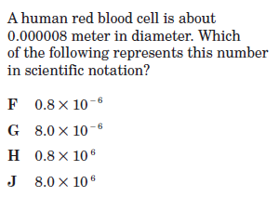  2. The population of Asia is about 3.4 x 10⁹. The population of Africa is about 7 x 10⁸. About how many more people live in Asia than live in Africa?  A. 27,000,000  B. 270,000,000  C. 360,000,000  - 2,700,000,000  3. The diameter of a barium atom is 0.0000004346 millimeters. In scientific notation it is  A. 43.46 x 10⁻⁸ mm  B. 4.346 x 10⁷ mm  C. 4.346 x 10⁻⁷ mm  D. 4346.0 x 10⁻⁷ mm  4. Evaluate (4.67 x 10⁷) (3.24 x 10³).  A. 1.51308 x 10¹¹  B. 1.51308 x 10²¹  C. 7.91 x 10¹⁰  D. 15.1308 x 10¹⁰  5. 648,392 in scientific notation is—  A. 648.392 x 10³  B. 6.48392 x 10⁵  C. 6.48392 x 10⁻⁵  D. .648392 x 10⁻⁶  13.  14.  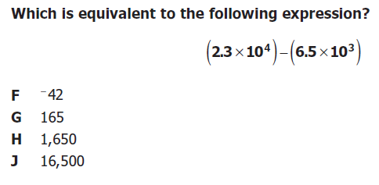  15.  16. | 6. Which expression represents 238.42 in scientific notation?  A 2.3842 x 10⁵  B 2.3842 x 10⁴  C 2.3842 x 10³  D 2.3842 x 10²  7. Which expression represents 0.000362 in scientific notation?  A 3.62 x 10⁻⁶  B 3.62 x 10⁻⁵  C 3.62 x 10⁻⁴  D 3.62 x 10⁻³  8. Which expression represents 0.783 in scientific notation?  A 7.83 x 10⁻²  B 7.83 x 10⁻¹  C 7.83 x 10¹  D 7.83 x 10²  10. Which expression represents 348,000 in scientific notation?  A 3.48 x 10⁴  B 3.48 x 10⁵  C 3.48 x 10⁶  D 3.48 x 10⁷  11. Which expression represents the product of 0.000008 and 3,500,000?  A 11.5 x 10³  B 2.8 x 10¹  C 2.8 x 10⁴  D 28 x 10⁴  12. Which expression represents the product of (4.63 x10⁸) and 500?  A 2.315 x 10⁴  B 2.315 x 10⁶  C 2.315 x 10¹¹  D 2.315 x 10¹⁶  17.  18. What is 253,000,000 in scientific notation?  A $\text{25}\text{.}3×{\text{10}}^{7}$  B $2\text{.}\text{53}×{\text{10}}^{8}$  C $\text{253}×{\text{10}}^{6}$  D $2\text{.}\text{53}×{\text{10}}^{9}$  19. Simplify: $\frac{9\text{.}0×{\text{10}}^{7}}{3\text{.}0×{\text{10}}^{\text{14}}}$  A $3\text{.}0×{\text{10}}^{−7}$  B $3\text{.}0×{\text{10}}^{−2}$  C $3\text{.}0×{\text{10}}^{2}$  D $3\text{.}0×{\text{10}}^{7}$  - Simplify: $\frac{1\text{.}\text{65}×{\text{10}}^{\text{25}}}{3\text{.}3×{\text{10}}^{5}}$  A $5\text{.}0×{\text{10}}^{4}$  B $5\text{.}0×{\text{10}}^{5}$  C $5\text{.}0×{\text{10}}^{\text{19}}$  D $5\text{.}0×{\text{10}}^{\text{20}}$  Bonus:  1.  