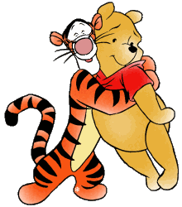  a | the | can
like | is | big
look | see | my

at | I | am
in | it | but
we | little | have

not |  | one  that
my |  | two  go
like |  | two

do | not | what
here | to | up
get | and | where

