Write congruent or not congruent.
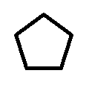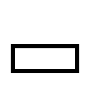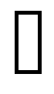
__________________ ___________________ ____________________

_________________ ___________________ _____________________

Write flip, turn, or slide.

____________ ______________ ________________

_____________ ______________ _________________

