Vocabulary Terms and Examples
Right in the space below the definition in your own words.
As a class if you are allowed to use the computers start looking up examples of each words for better understanding.
 | content: the subject, topic or information captured in a photograph.
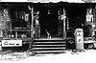 | direct approach: confronting a scene in a straight-forward manner, without using unusual angles or distortion.
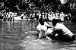 | documentary photography: photographs whose main purpose is to record a place, person(s) or event.
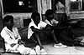 | expressive: concerned with communicating emotion.
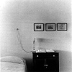 | geometric shape: simple rectilinear or curvilinear shapes found in geometry, such as circles, squares, triangles, etc.
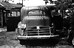 | 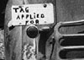  intention: reason(s) why the artist made a work of art.
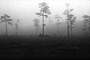 | landscape: an image that portrays the natural environment.
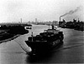 | objective: a point of view free from personal bias, which attempts to consider all available information with equal regard and fairness.
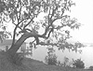 | organic shape: shapes based on natural objects such as trees, mountains, leaves, etc.
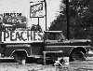 | representational: an image which shows recognizable objects.
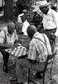 | subject: the main object or person(s) in a photograph.
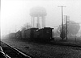 | theme: a unifying or dominant idea in one work of art or in a collection of works.

