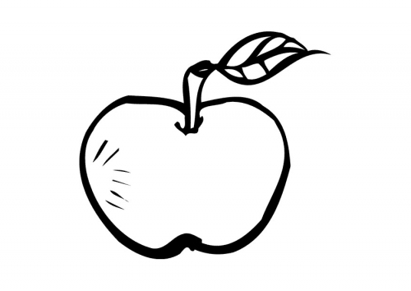
Mrs. Bailey’s
News

September 21, 2015
Riverdale Elementary School
Mrs. Hannah Bailey
hbailey@southampton.k12.va.us
(757) 562-3007

HomeWOrk:

Homework
Monday- Count to 30
Tuesday- Read your library book.
Wednesday- Trace your first name. Write it two times like the example.
Thursday- p.60(shapes)

Reading
- Big Book: Building With Dad
- Book: What Makes a Family
- Poem: Frere Jaques”
- Letter: Kk, Ll, Mm, Nn, Oo
- Sight Words: I
Math
- Identify, describe, trace, compare and group geometric figures, distinguish between examples of and non-examples of identified geometric figures.
Unit Study (Science/Social Studies)
- Investigate and understand that humans have senses that allow them to seek, find, take in, and react or respond to information in order to learn about their surroundings.

We’re Learning…

VA SOL

Reading- K.1 K.5 K.9 K.7 K.6
Math-K.11 K.12
Unit Study- K.2
Take note:
*Be sure to wear appropriate gym shoes on Monday!
* Students will check out library books on Tuesdays. Be sure to return the old one so you get a new one!
*Thank you to the parents who brought snack on their assigned day. Don’t forget to check the folder calendar for your day.

