Mrs. Dickens’
First Grade News
September 11-15 2017

Learning in the Jungle!

Reading
Informational Text – What is a Pal?
Phonics – consonants d, n, p, f
Short a
Reading Skill – Main Idea
High Frequency Words – be, help, you, with
and, play

Grammar/Writing
Nouns
Handwriting/Journal Writing

Math
1.16 Sorting and Classifying
1.1 Count and Write to 100

Social Studies
1.10 Citizenship

Noteworthy Happenings
9/18 PALS Testing Begins

Homework

Please remember I do not give formal homework. However, I do request that you:
**Read with your child 20 minutes each night.
**Review high frequency words with your child each night
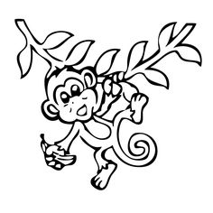
Please remember to review and initial your child’s behavior calendar nightly! ☺
Also, please remember to check in periodically on Classroom Dojo. If you have not yet signed up yet, please do so! ☺

Mrs. Dickens’ Resource Schedule
Time: 2:10-2:50
Monday | Library
Tuesday | NO RESOURCE
Wednesday | P.E. (Dress appropriately)
Thursday | Music
Friday | Library

Mrs. Dickens’ Tentative Classroom Schedule
8:15-8:40 Morning Work (Breakfast/RR/Water)
8:45-9:05 Word Study
9:10-9:30 Calendar and Whole Group Reading
9:35-10:50 Small Group/Literacy Stations
10:55-11:55 Math
12:00-12:20 Grammar/Writing
12:25-12:55 Lunch
1:00-1:25 Read-Aloud and Restroom Break
1:30-2:05 Social Studies/Science
2:10-2:50 Resource
2:55-3:05 Pack Up
3:10-3:40 Recess (Water/Restroom)
3:45 Dismissal

