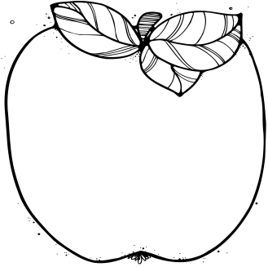

**Please sign up for Remind text messages from me, if you haven’t already. I am sending important messages through this system. Text the number 81010, and in the message line, type “@mrsafowler”.**

-Wednesday, there will be no school for students.

# Important Dates:

Reminders:.

**\**Many students are without some supplies they need for school. Please ask your child if they still have plenty of crayons, glue sticks, notebooks, scissors, etc. Thanks so much!***

What We’re Learning:  
**Reading:** Story—Mr. Tanen’s Tie Trouble; Vocab—account, budget, chuckled, disappointed, fund, received, repeated, starting; skill

**Math: We will finish our unit on money. Please help your child count various amounts of coins and bills up to $2.00.**

**Social Studies:** Ancient Egypt—Test will be Thursday. Students need to study all notes in their social studies notebook.

January 30, 2017

Contact Me: [afowler@southampton.k12.va.us](mailto:afowler@southampton.k12.va.us) or 562-3007

M

Mrs. Fowler’s   
 Newsletter